**Managing Virtual Private Cloud (VPC)**

* VPC is the backbone of the AWS cloud platform. In order to become an AWS Solutions Architect, Must have a better understanding of the AWS VPC and Its components.
* if you are from the Networking, background, Managing VPC might be very easy for you, However, candidates from the developing background should spend a good amount of time to get familiarized with the AWS VPC and its Components such as Internet Gateways, NAT Gateways, Routing tables, VPC Peering, Subnets et, We have covered all these components in details in the separate sections, VPC is a separate, isolated, private network in the AWS cloud.
* By default, the instances from one VPC, another VPC cannot communicate to each other, for some reasons, we may need to have multiple VPN in the AWS cloud.
* One use case of having multiple VPCs is that suppose we want to keep our 7 developments and production instances logically isolate to each other.

**Recommended links:**

* Getting started with AWS VPC.
* <http://docs.aws.amazon.com/AmazonVPC/latest/GettingStartedGuide/getting-started-ipv4.html>)

Creating VPC in AWS Cloud

In order to create a VPC, you need to perform the following steps:

1. In the AWS console, search and open the VPC dashboard.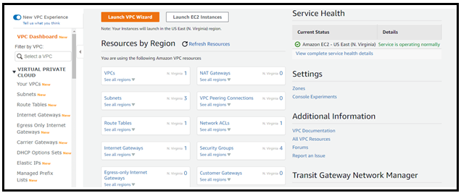
2. Click the with Start the VPC Start Wizard option shown in the following figure.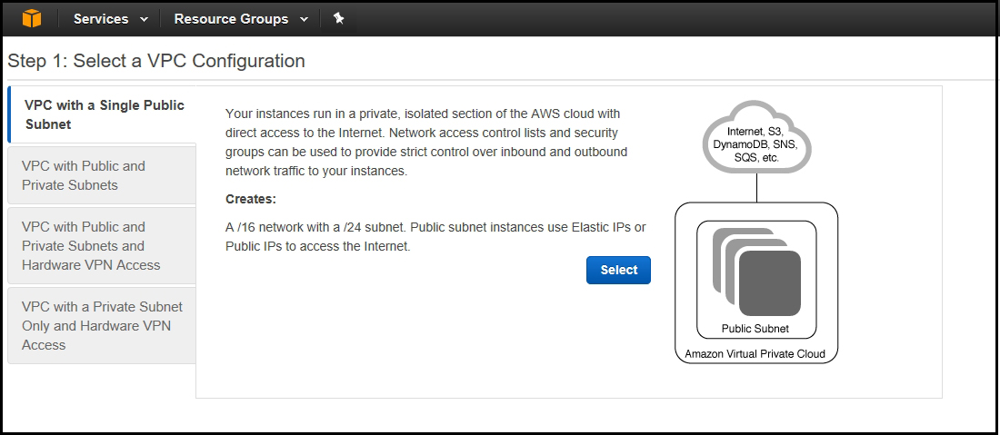
3. On the Select a VPN Configuration page, click each of the VPC Configuration options and review the description of the features provided by them.
4. Depending on your requirement, select the appropriate VPC configuration. Here, we will select the VPC with a Public Subnet option as shown in the following figure.
5. On the next page, specify the VPC name, subnet range, and Availability zone etc. Here we are going to specify the following values:

* **IPv4 CIDR Block:** 10,50.0.0/16
* **VPC Name:** My_Test_VPC
* **Public Subnet CIDR:** 10.50.1.0/24
* **Availability Zone:** Select the first availability zone.
* **Subnet Name:** Public_Subnet1

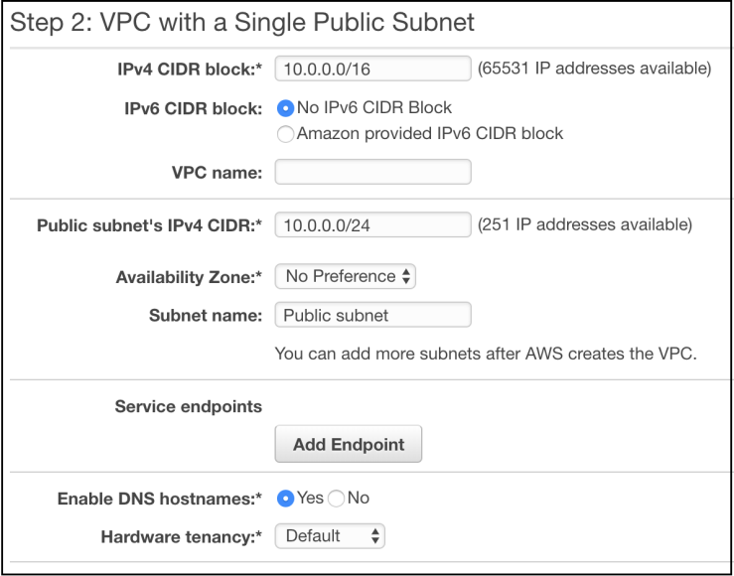

1. Click the Create VPC button to proceed next. The VPC will be created and available in the VPC list as shown in the following figure.

**Creating and Adding Private Subnet in the Existing VPC**

* Once we had selected the VPC with a public subnet option, so need to create a private subnet separately. A private subnet does not have direct access from the outside AWS network such as the internet. All Private subnet require a NAT gateway to access the internet. Typically backed and database servers should always belongs to the private subnets.

If you are interested, you can visit the following link to know more about the AWS VPC and subnets.

* AWS VPC and subnets Getting Started.
* <Http://docs.aws.amazon.com/amazonVPC/Iatest/UserGuide/VPC_Subnets.html>

To create a private subnet, you need to perform the following steps

1. Select the Subnets option in the navigation pane and then click Create Subnet.
2. On the Create Subnet page, specify the following values:
   * **Name tag:** Name of the subnet
   * **VPC:** Select the VPC in which you want to create the subnet
   * **Availability Zone:** Select the zone in which you want to create the subnet
   * **IPv4 CIDR block:** Specify the subnet IP range which must be within the VPC CIDR range.
3. For our lab exercise, let’s create a Private subnet with the following values:
   * **Name tag:** Private_Subnet1
   * **VPC:** My_Test_VPC
   * **Availability Zone:** ap-southeast-2b
   * **Iv4 CIDR block:** 10.50.2.0/24

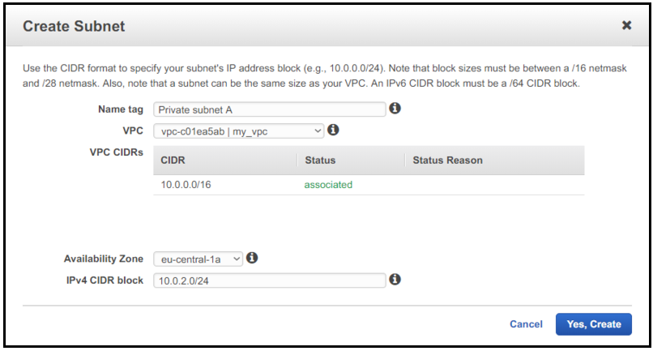

1. Click the Yes Create button to proceed. A new private subnet will be added to your existing VPC.

**Deleting VPC**

If you no longer require any VPC for any reason, you can delete it anytime. For this, just select the VPC you want to delete, click Actions and then select Delete VPC to delete it as shown in the following figure.

